**MDSC – 103(p)**

**Regd No: 22228  
OPTIMIZATION TECHINQUES LAB**

**Name: Akula Venkata Satya Sai Gopinadh**

Question A:

Imagine a furniture company that makes tables and chairs. A table requires 40 board feet of wood and a chair requires 30 board feet of wood. Wood costs $1 per board foot and 40,000 board feet of wood are available. It takes 2 hours of skilled labour to make an unfinished table or an unfinished chair. Three more hours of labour will turn an unfinished table in to a finished table; two more hours of skilled labour will turn an unfinished chair into a finished chair. There are 6000 hours of skilled labour available. (Assume that you don’t need to pay for this labour.)

The prices of the output are given in the table below:

|  |  |
| --- | --- |
| PRODUCT | PRICE |
| Unfinished Table | $ 70 |
| Finished Table | $ 140 |
| Unfinished Chair | $ 60 |
| Finished Chair | $ 110 |

1. Formulate an LP that describes the production plans that the firm can use to maximize its profits.

Maximize  
 Z= 70 x1 + 140 x2 + 60 x3 + 110 x4  
Subject to:

40 x1 + 0 x2 + 30 x3 + 0 x4 <= 40,000  
2 x1 +5 x2 +2 x3 + 4 x4 <= 6000  
x1, x2, x3, x4 >= 0

x1 = no of tables unfinished  
x2 = no of tables finished  
x3 = no of unfinished chairs  
x4 = no of finished chairs

2. What would happen if the prices of unfinished chairs went up?  
If the prices of the unfinished chairs went up then the optimum value would also increase. This can be seen with the sensitivity analysis report generated that shows that the allowable increase is 6.5

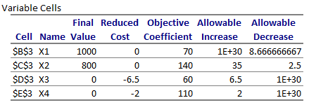

3. What would happen if the prices of the unfinished tables went up?

If the prices of the unfinished tables went up then the optimum value would also go up as seen in the sensitivity analysis report. The report shows that the allowable increase is 1E+30.

**4.** What would happen if the finished chairs fell to $100?

If the prices of the finished chairs fell to $100 from $110 it would not affect the optimum  
value hence there is no difference in the profit of the goods sold by the furniture company.

5. How would profit change if lumber supplies changed?

If the lumber prices are reduced the profits would also decrease. If the lumber prices are  
increased then the profit is also increased hence we can conclude that the wood prices  
determine the profit of the company.

If the RHS of the C1 is Changed to 30,000 from 40,000:

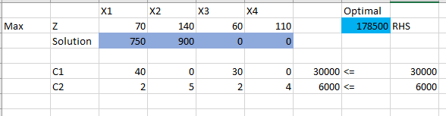

If the RHS of the C1 is Changed to 50,000 from 40,000: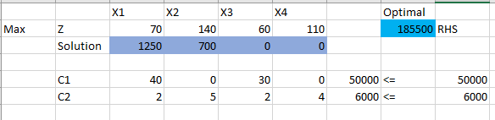

6. How much would you be willing to pay an additional carpenter?

If an additional carpenter is hired then the production will go up as the two carpenters  
would work parallelly and hence it would take less time to finish the products hence would  
bring in more profits. Hence the carpenter can be paid the same amount or could be given  
more than the previous carpenter. Suppose the initial carpenter was earning $100 for every  
product he manufactures, then the additional carpenter can earn anywhere between $100  
to $110 dollars.

7. Suppose that industrial regulations complicate the finishing process, so that it takes extra hour per chair or table to turn an unfinished product into a finished one. How would this change your plans?

If the industrial regulations complicate the finishing process and it takes extra hour per chair  
of table then the profits of the company decrease and the customer have to wait for much  
longer for the products to be made and delivered.

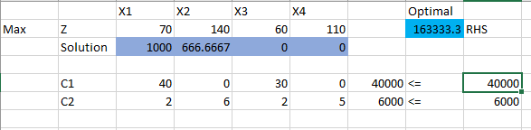

**8.** The owner of the firm comes up with a design for a beautiful hand-crafted cabinet. Each cabinet requires 250 hours of labour (this is 6 weeks of full-time work) and uses 50 board feet of lumber. Suppose that the company can sell a cabinet for $200, would it be worthwhile?

The problem then changes as:

Maximize:

Z= 70 x1 + 140 x2 + 60 x3 + 110 x4 + 0 x5 + 200 x6

Subject to:

40 x1 + 0 x2 + 30 x3 + 0 x4 + 50 x5 + 0 x6 <= 40,000

2 x1 +5 x2 +2 x3 + 4 x4 + 0 x5 + 250 x6<= 6000

x1, x2, x3, x4, x5, x6>= 0

x1 = no of tables unfinished  
x2 = no of tables finished  
x3 = no of unfinished chairs  
x4 = no of finished chairs  
x5 = no of unfinished cabinets  
x6 = no of finished cabinets

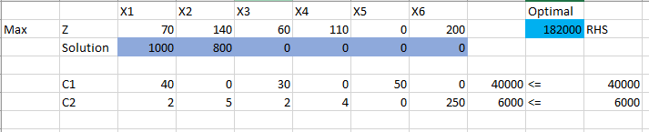

**Even by adding CABINETS manufacturing, there is NO INCREASE or DECREASE in the Profits of the Company**